Student: ___________________________________
Group: ____________________________________
Lecturer: A.S. Eremenko
Homework 6
1. What is a random variable:
1

a) a possible outcome;
b) the numerical value;
c) the experimental value;
d) a real-valued function of the experimental outcome?
2. A random variable is called discrete if:
1

a) it can be conditioned on another random variable;
b) its range is finite or at most countably infinite;
c) the set of values that it can take is uncountably infinite;
d) it can be independent from an event of from another random variable.
3. A discrete random variable has an associated:
1

a) PMF;
b) PDF;
c) function of random variable;
d) real-valued function.
4. If $x$ is any possible value of $X$, the probability of the event $\{X=x\}$, consisting of all outcomes that give rise to a value of $X$ equal to $x$, is:
1

a) the probability density;
b) the probability mass of $x$;
c) $p_{X}(x)$;
d) the variance of $X$.
5. Which from the listed below properties are true for a probability density functions:
a) for any subset $B$ of the real line $P(X∈B)=\int_{B}{f_{X}(x)dx}$;
1

b) $\sum_{x}{p_{X}\left(x\right)}=1$;
c) $\int_{-∞}^{∞}{f_{X}(x)dx}=1$;
d) $P(a≤X≤b)=\int_{a}^{b}{f_{X}(x)dx}$?
6. What can be interpreted as the area under the graph of the PDF:
a) $P(X=a)=\int_{a}^{a}{f_{X}(x)dx}=0$;
1

b) the probability that the value of $X$ falls within an interval;
c) $P(a≤X≤b)=\int_{a}^{b}{f_{X}(x)dx}$;
d) entire area under the graph of the PDF must be equal to 1?
7. What provides cumulative distribution function $F_{X}\left(x\right)$:
1

a) the probability $P(X=x)$;
b) the probability $P(X≤x)$;
c) probability mass per unit length;
d) area under the graph of the PDF.
8. Indicate $y$-axis on graphs and corresponded RV (continuous or discrete):
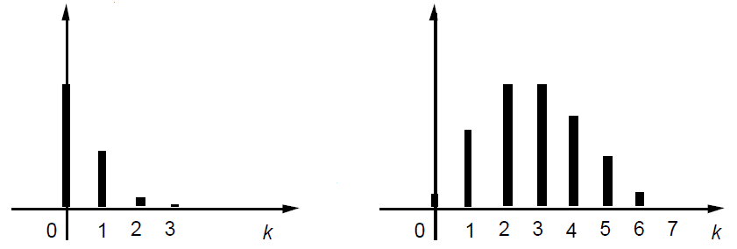
3

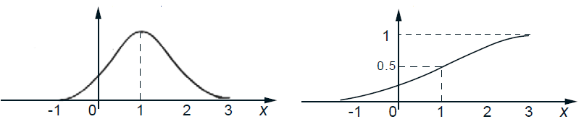

Problem 1. Show graphically PMF and corresponding CDF of discrete random variable $X$ of number of failures of the router during the day, if:
$P(X=0)=0.05$, $P(X=1)=0.1$, $P(X=2)=0.5$, $P(X=3)=0.3$, $P(X=4)=0.05$.
5

Solution:

Problem 2. No failure operating time of some device has an exponential PDF:
$f_{X}\left(x\right)=0.01e^{-0.01t}$, $t>0$, where $t$ – time in $hours$.
Find the probability that device will operate without failures during $100 hours$.
Solution:
5

20

